**IAM Role**

* Search IAM in AWS service
* Select IAM

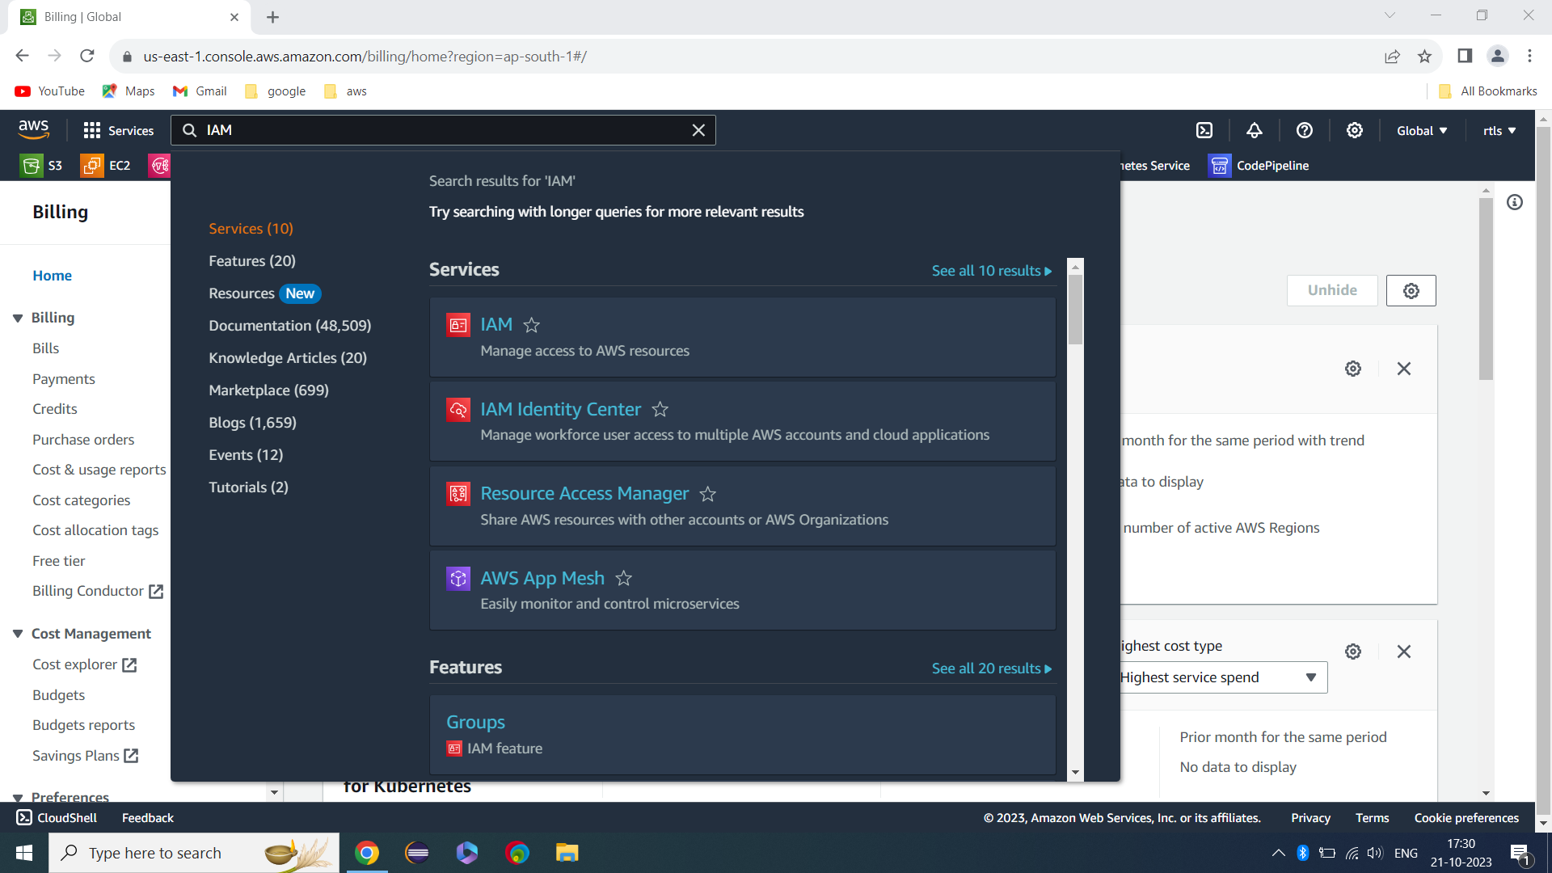

* Select Role
* Click on Create Role
* Select usecase as EC2
* Hit Next

Permission

**Give below permission**

* IAMFullAccess and listed below
* Then hit next

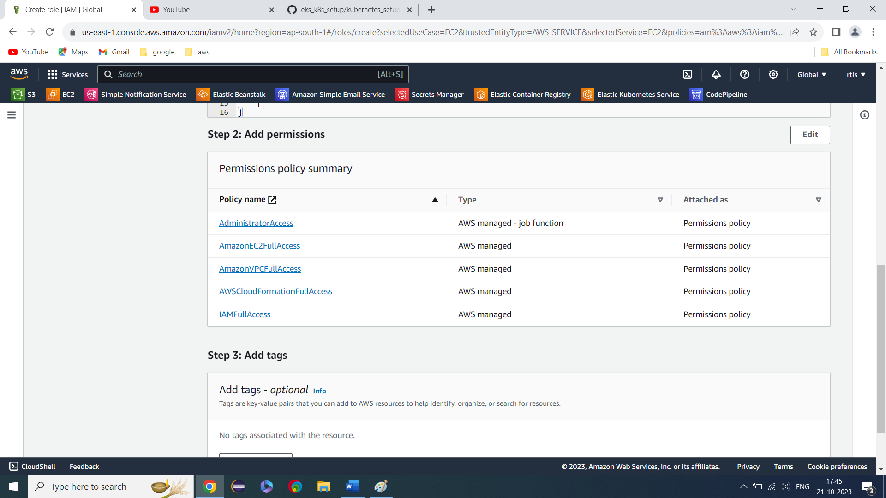

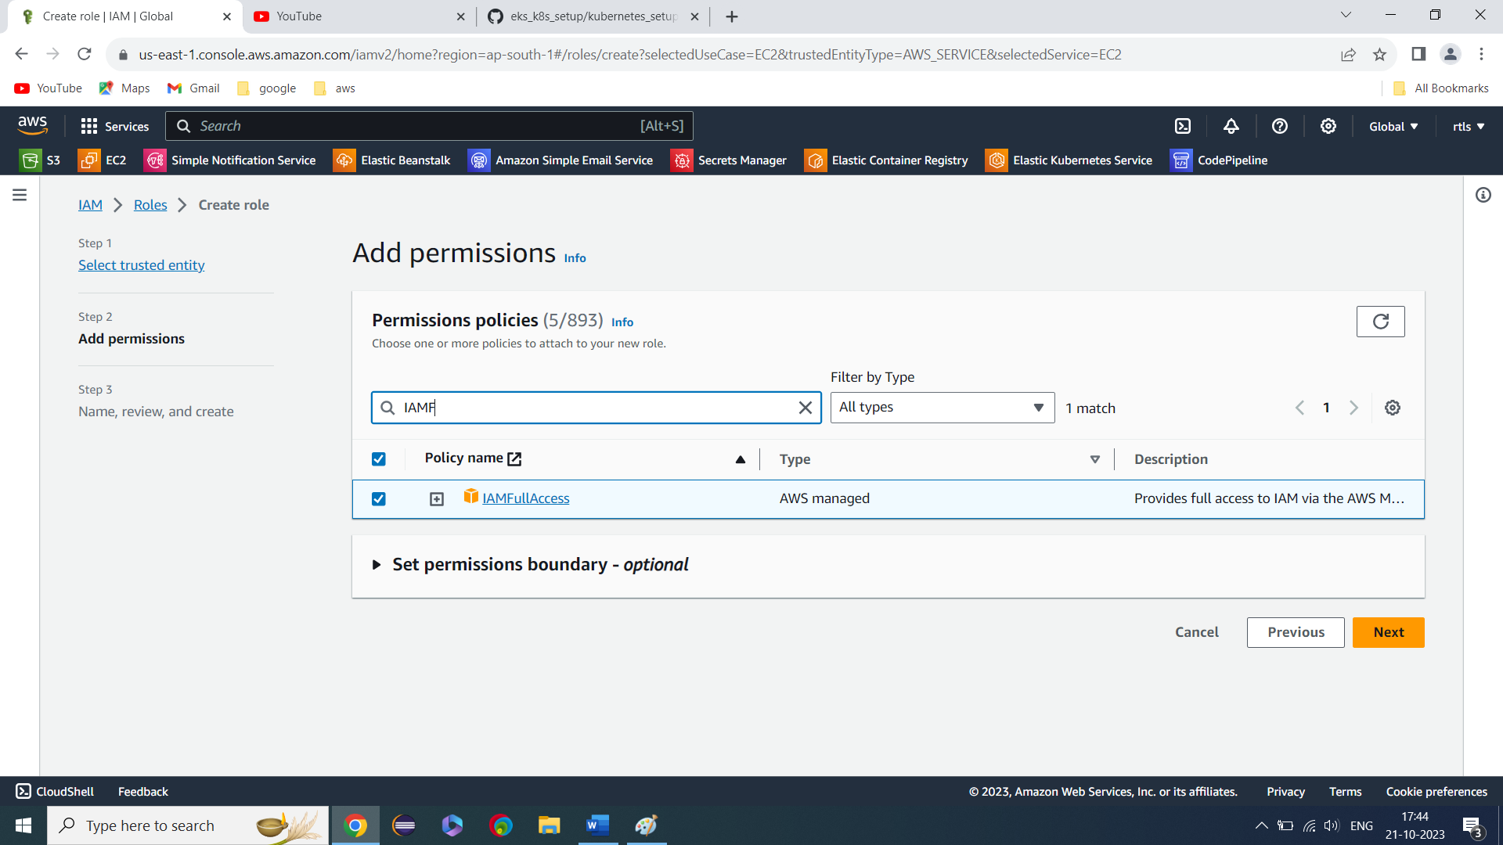

* Give Role Name and hit Create Role